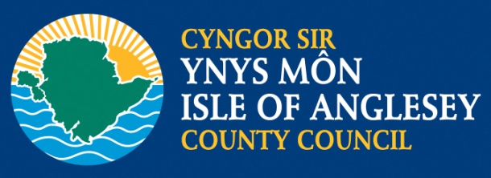

FFORWM YSGOLION MÔN SCHOOLS FORUM

**DYDD LLUN 24 MAWRTH 2014 AM 6.00yh**

**YN SIAMBR CYNGOR SIR YNYS MÔN, LLANGEFNI**

**MONDAY 24 MARCH 2014 AT 6.00pm**

**AT THE ISLE OF ANGELESY COUNTY COUNCIL CHAMBERS, LLANGEFNI**

# **RHAGLEN/AGENDA**

1. Croeso ac ymddiheuriadau/ Welcome and apologies
2. Datganiad o ddiddordeb/ Declaration of Interest
3. Cofnodion y cyfarfod blaenorol/ Minutes of the previous meeting
4. Materion yn codi o’r cyfarfod blaenorol/Matters arising from the previous meeting

* Cytundebau Lefel Gwasanaeth/Service Level Agreements
* Diweddariad ar gyllideb 2014-15/Update on the budget
* Dilyniant i adroddiad y Grŵp Tasg a Gorffen AAA/

Follow up to the SEN Task and Finish Group

* Ymweliad Monitro Estyn/Estyn Monitoring visit

1. Grant GEY/GAD/ SEG/PDG Grant
2. Unrhyw fater arall/Any other business