**New Developments and opportunities**

Exciting changes and developments are happening at Llangollen Museum in partnership with the National Museum of Wales.

Funded by CyMAL and the Heritage Lottery Fund a new exhibition is planned for June 2014 to highlight the joint story of two of Llangollen’s most important local historic sites, Valle Crucis Abbey and the nearby Pillar of Eliseg.

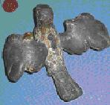

In order to achieve this the museum is fortunate to be included in the National Museum of Wales Sharing Treasures scheme, funded by the Welsh Government, which will see the six month return to Llangollen of a number of interesting and significant artefacts associated with the Abbey and the surrounding area.

The museum is also in a fortunate position to showcase the results and finds of the recent archaeological excavations at the Pillar of Eliseg in partnership with both Bangor University and the University of Chester.

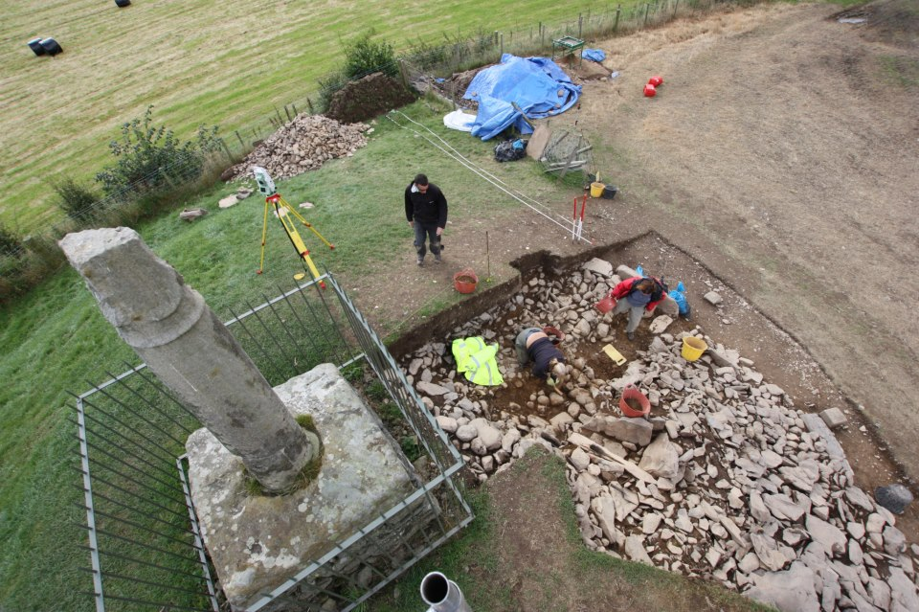

The Sharing treasures project and the Pillar of Eliseg excavations give us the unique opportunity to tell the stories of Llangollen’s long and important history ranging from prehistory through early medieval times to the heyday of the monastic presence at Valle Crucis Abbey.

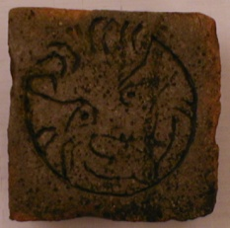

**What Sharing the Treasures can offer you**

The new exhibition will compliment both key stages 2 and 3 of the National Curriculum, and a number of different resources will be available for schools and pupils to utilise:-

* The children/students will be able to look at the original artefacts from the National Museum, handle reproduction copies and examine the items in 3D detail on the computers and then compare the items with their modern day equivalents. The students will also be able to handle original artefacts from the Abbey/Pillar site that are in the Llangollen Museum collection.

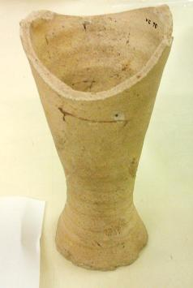

* The students will be able to walk into a recreation of the Chapter House in the museum, where they will be able to view items found on the site as well as watching a 3D virtual tour through the Abbey and discover more about the history of the Abbey and Pillar using the interactive computer timeline.
* Costumes from different periods in history associated with the Abbey/Pillar site will be available for children to try on.



* A worksheet and quiz based on displays and computer timelines will be available for the pupils to complete.
* By arrangement one of the museum curators will be able to give the children a short presentation about the history of the site. The presentation is highly pictorial and includes lots of questions - why, what, how and who do you think…? in order to make them think more about the history of the Abbey/Pillar site.

All the available resources will help the children better understand the long history of Llangollen and the Pillar/Abbey site as a significant place of occupation and the importance of the monastic presence of the Cistercian order in both Llangollen and the whole of Wales.

**See the exhibition, visit the site!**

With both Valle Crucis Abbey and the Pillar of Eliseg on our doorstep this provides a good opportunity to combine a visit to the museum with a visit to the actual locations to enhance the learning experience. The project will be able to help with the cost of transport to the Museum and the Abbey/Pillar site and curators from the Museum will be available to give a guided tour around the Abbey and up to the Pillar to explain to the students their significance to the history of the local area and Wales.

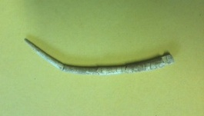

**How Sharing the Treasures**

**Fits into the National Curriculum**

Because the Abbey/Pillar site has been occupied over a long period of history it provides a unique local opportunity to study history that directly relates to the following aspects of the National Curriculum:-

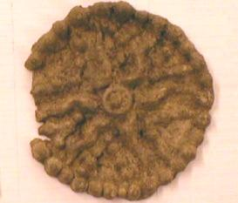

* A class timeline – the students are actively involved in choosing the dates and images to be included.
* At Key Stage 2, comparisons should be made between the daily lives of people in the range of contexts investigated.
* Using a range of different interpretations and representations.
* Using a wide variety of sources. The use of a range of sources, including artefacts, photographs, buildings, sites is mandatory at Key Stage 3, and desirable at Key Stage 2.
* Structuring visits into the scheme of work.

**How to Find Out More and Make Use of**

**This New Resource**

The best way to get more information, book a visit or arrange a trip to the site is to e-mail the museum on:-

[enquiries@llangollenmuseum.org.uk](mailto:enquiries@llangollenmuseum.org.uk)

or telephone 01978 862862

mobile 07852 726934

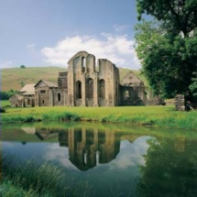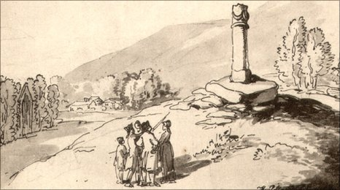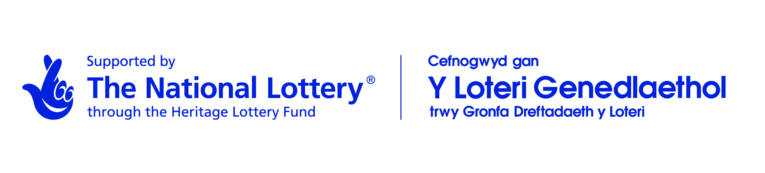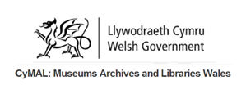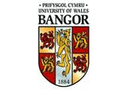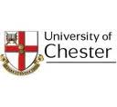

**Sharing the Treasures**

**of Valle Crucis Abbey and Eliseg’s Pillar**

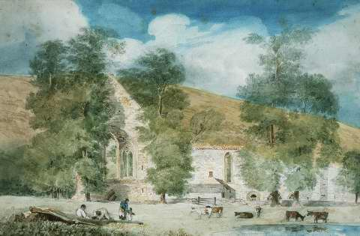

**A New Educational Opportunity**

**For Local Schools**

June 2014 - Early 2015

Presented by Llangollen Museum

in partnership with the

National Museum of Wales

