How can SACRE monitor standards?
Standing Advisory Council for Religious Education (SACRE)

SACRE’s main function is to monitor religious education and collective worship and to advise the local authority on matters relating to religious education and collective worship. The Wales Association of SACREs believes that this advice should be based on current information. Many SACREs monitor standards by inviting schools to share their self-evaluation of Religious Education and collective worship with SACRE members.

Further Information:
- Wales Association of SACREs: www.wasacre.org.uk
- Religious Education and Collective Worship: Circular 10/94 (Welsh Office)
- So You’re Joining Your Local SACRE: a handbook for SACRE members in Wales (WASACRE)
- Guidance on Collective Worship (WASACRE, 2012);
- Review of SACRE reports (Welsh Government, 2011 and 2013)

Department for Education and Skills Wales (DfES)

Most SACREs in Wales have adopted or adapted the ‘National Exemplar Framework for Religious Education for 3 to 19 year olds in Wales’ as their locally agreed syllabus. The Welsh Government has supported the teaching of religious education in schools by providing guidance documents to support teachers, head teachers and SACRE members. These provide useful information about teaching methods, resources and assessment. The 2010-12 national external verification process gave RE departments in secondary schools the opportunity to show their understanding of RE attainment levels.

Further information
- http://wales.gov.uk > search for Religious Education
- Locally Agreed Syllabus (or National Exemplar Framework for Religious education in Wales)
- Religious Education: Guidance for KS2 and KS3 (2011)
- Exemplifying Learner Profiles at KS2 and KS3 in Religious Education: Additional Guidance (2011)
- Religious Education: Guidance 14-19 year olds (2009)
- People, Questions and Beliefs in the Foundation Phase (2013)
- Religious Education: Chief Moderator’s Report 2012 (http://wjec.co.uk )

ESTYN
The new ESTYN inspection framework identifies five inspection areas or reporting requirements:

- Standards
- Wellbeing and attitudes to learning

- Teaching and learning experience
- Care, support and guidance
- Leadership and management

Few school inspection reports include references to the standard and quality of Religious Education and collective worship.
Further information:
- www.estyn.org.uk
- Religious Education in Secondary Schools (ESTYN, June 2013)
- Religious and moral education in key stage 2 and key stage 3 (ESTYN, Summer 2018)
- Supplementary guidance : collective worship in non-denominational schools (ESTYN, Autumn 2017)

What evidence do schools use in order to make judgements?

Book Review  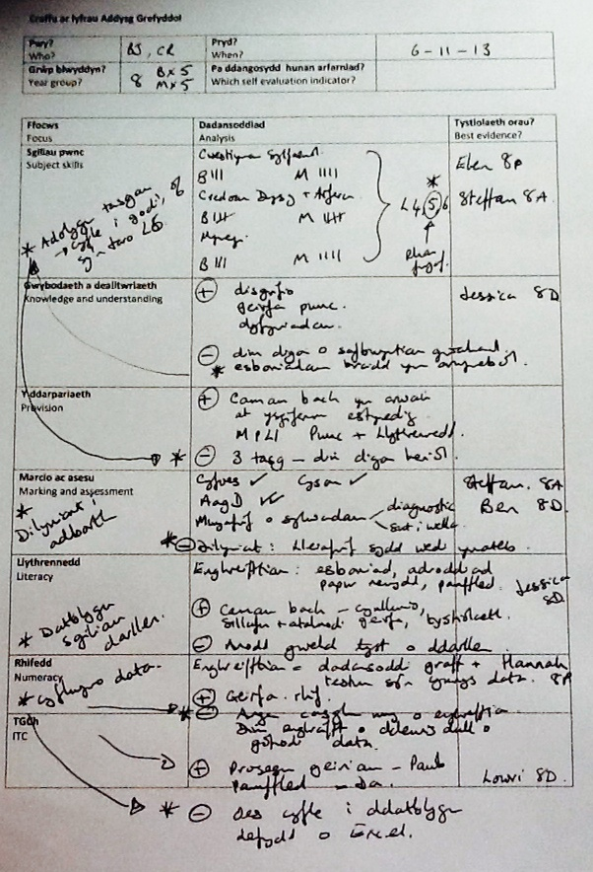 | Teachers will collect a sample of pupils’ work (e.g. range of abilities, ages, boys and girls) and will help the curriculum leader to answer questions such as:  - What progress are pupils making in their RE skills? Are there groups of pupils who are underachieving?  - To what extent does pupils’ work reflect the requirements of the Locally Agreed Syllabus?  - To what extent does pupils’ work develop the skills identified by the National Literacy, Numeracy and Digital Competence frameworks?  - What improvements do we need to make to our planning, provision and assessment of religious education?
Lesson Observation  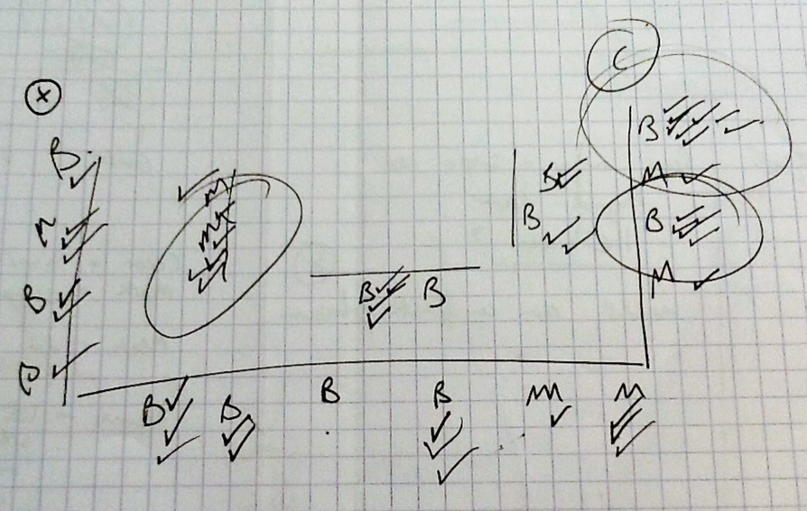 | Teachers and school leaders will observe lessons and will help the curriculum leader to answer questions such as:  - What progress are pupils making in their RE skills? Are there groups of pupils who are underachieving?  - Are the pupils well motivated? Are they contributing to their own learning?  - Does the work reflect the requirements of the Locally Agreed Syllabus?  - Does the work develop the skills identified by National Literacy, Numeracy Digital Competence framework?  - What improvements do we need to make to our planning, provision and assessment?
Questionnaires and interviews  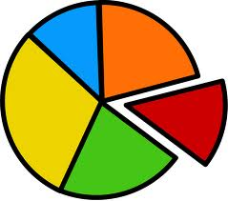 | Schools can analyse the results of questionnaires used with pupils, teachers and parents to answer questions such as:  - What do they think about the content of the RE lessons? Are there significant groups who are offering different opinions?  - What progress are they making in their RE skills?  - What are their perceptions/attitudes/opinions?  - What improvements do we need to make to our planning, provision and assessment of religious education?
Data  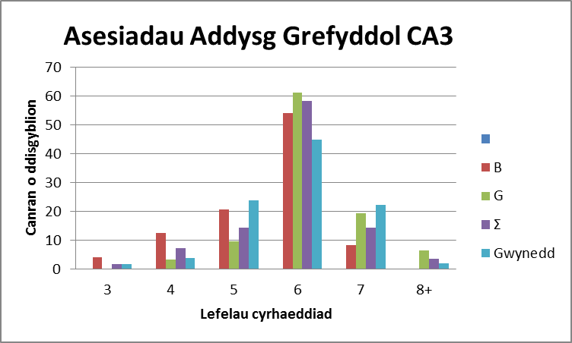 | Schools can use teacher assessment data or external examination results (secondary schools only) in order to identify trends or patterns.  - How well are boys/girls/groups performing over time? (all schools)  - How well are our pupils performing in comparison with other departments/other schools? (secondary schools only)  - Are there any groups of pupils who are underachieving? (all schools)  - What improvements do we need to make to our planning, provision and assessment of religious education?
Other  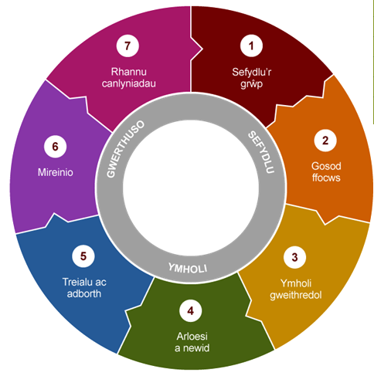  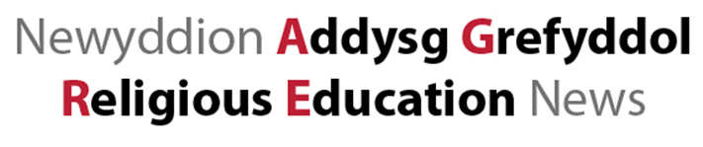 | Schools can also base their judgements on other evidence such as,  - Success in local or national RE competitions;  - Participation in local or national RE  events/conferences/projects/publications;  - Monitoring reports by other members of staff, e.g. school literacy, numeracy or ICT co-ordinators;  - Minutes of meetings held with teachers, school governors or SACRE visitors.  - Action research undertaken by a member of a Professional Learning Community;  - External accreditation, e.g. RE Quality Mark

SACRE Guidance

To what extent does the school’s provision promote pupils’ personal development? (Inspection area 4.2)
Evaluating the standards and provision of religious education will help schools evaluate inspection area 4.2, ‘Personal development (including spiritual, moral, social and cultural development).

ESTYN’s inspection guidance (September 2017) for social and moral development notes:
“Inspectors should consider the extent to which the school provides effective opportunities for pupils to develop secure values and to establish their spiritual and ethical beliefs. They should consider how well the school develops pupils’ ability to reflect on religious and non-religious responses to fundamental questions and to reflect on their own beliefs or values. They should consider how well the school promotes principles that help pupils to distinguish between right and wrong. They should consider how far the school fosters shared values, such as honesty, fairness, justice and sustainability, and helps pupils to understand the needs and rights of others, both locally and as members of a diverse global world.”

Within the school’s self-evaluation cycle or calendar, school leaders will need to consider what evidence is available to them in order to make an evaluative judgment on Inspection Areas 4.2. Religious Education and collective worship can make important contributions to pupils’ personal development.

The following exemplar questions are based on ESTYN’s Common Inspection Framework (September 2017) and the questions used by ESTYN during the thematic review of religious education during the autumn term of 2017. Using these prompt questions with staff, governors, pupils and their Supporting Improvement Adviser, will enable schools to identify strengths and weaknesses to help them to plan improvements. There is no need to answer every question.

Inspection Area 1: Standards
Remember to use qualitative and evaluative language and include ‘real’ examples of pupils’ work!
- What is our view on standards of religious education in our school? (FP, KS2, KS3, KS4, KS5 pupils)
- How well do our pupils engage with fundamental questions, explore religious beliefs, teachings and practice(s) and express personal responses to beliefs, teachings, practices and fundamental questions?
- How well do groups of pupils make progress in religious education? What have we identified in their work that shows their progress?
- How well do our pupils use their speaking and listening, reading and writing skills, their numeracy and ICT skills appropriately in religious education?
- Give examples of how our pupils have developed their thinking skills, their creativity and physical skill in religious education activities in the classroom and outside the classroom.
- What do we need to do differently in order to improve?

Inspection Area 2: Wellbeing and attitudes to learning
Remember to use qualitative and evaluative language and include ‘real’ examples of pupils’ work!
- Do our pupils show an interest in religious education?
- What do you think our pupils gain from religious education?
- What do we need to do differently in order to improve?

Inspection Area 3: Teaching and learning experience
Remember to use qualitative and evaluative language and include ‘real’ examples of the provision. Time allocated to religious education? % of pupils that choose Religious Studies as an option? % of pupils who attain an accreditation for their statutory religious education.
- How do we know that our school meets the statutory requirements for religious education?
- How does our school teach religious education?
- Does religious education succeed to engage our pupils’ interest? Are they stimulated and challenged in their religious education lessons?
- How well do the lessons/activities develop pupils’ knowledge and understanding of religious beliefs, teachings and practices as well as their subject skills and cross-curricular skills?
- How good is our planning for religious education? (building on previous knowledge, understanding and skills? clear objectives? teaching methods? resources?)
- To what extend does the feedback in religious education help our pupils to know what they have achieved and what they need to do to improve?
- How do we assess and track the progress of pupils in religious education?
- How does our planning for religious education help pupils to become ambitious, confident, aspirational and knowledgeable individuals? How are we responding to the recommendations of ‘Successful Futures’?
- To what extend does our school provide a range of appropriate learning experiences, within the classroom and outside, in order to develop pupils’ interest and skills in religious education?
- Have we organised any trips or visits linked to religious education? Which year groups, how often, and how do these trips enhance the curriculum?
- Does the religious education reflect the nature of our school’s context? Does it reflect the cultural, linguistic and ethnic diversity of Wales and the local area?
- To what extend do the religious education activities provide purposeful opportunities for pupils to practise and develop their RE skills and their literacy, numeracy and ICT skills?
- What do we need to do differently in order to improve?

Inspection Area 4: Care, support and guidance
Remember to use qualitative and evaluative language and include ‘real’ examples of the provision.
- To what extent do our religious education lessons/activities help our pupils to be active citizens?
- How do our pupils influence what and how they learn in religious education?
- Do we participate in any community activities or have links with any faith leaders or organisations?
- How does religious education contribute to our pupils’ understanding of the culture of Wales, the local community and the wider world?
- How has religious education helped our pupils to understand equality and diversity? Stereotypes, religious extremism, human rights?
- Which effective opportunities do the school offer pupils to develop certain values and establish their spiritual and ethical beliefs?
- How effective is our school at developing the pupils’ ability to reflect on (extensive) fundamental questions from a religious or non-religious perspective? Their own beliefs or values?
- Does our school meet the statutory requirements regarding collective worship?
- How good is the collective worship? How well do we plan the collective worship over time?
- How do we keep our pupils safe from the dangers of radicalisation, e.g. extremist material, either through visiting speakers or through speakers on site visits?
- How do we respond to any concerns that arise about comments made by pupils during religious education lessons?
- What do we need to do differently in order to improve?

Inspection Area 5: Leadership and management
- Has the RE subject leader the necessary skills and understanding to lead the religious education effectively?
- Are teachers able to access professional development in religious education?
- How do we allocate resources to support the teaching of religious education?
- How are parents informed of their right to withdraw pupils from RE? How many pupils are withdrawn from RE by their parents and does the school have good arrangements for their provision during RE lessons? Has this number increased/decreased/remained the same over the last 5 years? From what groups do these pupils come? Do you have a conversation with parents around their decision is taken?
- In what ways does our school’s provision for RE help promote better community cohesion?
- How often do we monitor religious education? How do we share this information with staff?
- Do we consider the views of pupils in the self-evaluation report and improvement plans?
- Do we work with RE teachers from other schools? What has been the impact of this?
- What is the ‘best example of religious education’ that we can share with our local SACRE or with other teachers?
- What do we need to do differently in order to improve?

How can SACREs monitor standards?
How can SACRE gather information?
- By asking schools to submit information and self evaluation.
- By commissioning an ‘expert’ to visit a sample of schools and provide a termly report;
- By visiting schools themselves;
- By asking pupils, staff, governors in a sample of schools to complete an online questionnaire;
- By studying external examination results and KS3 teacher assessments, (secondary schools only)

Gather information
Analyse

Summarise
Make Judgement
Prepare action plan

What sources are available in your area?
- An evaluation of schools’ self evaluation reports;
- An evaluation of schools’ policies, schemes of work, development or improvement plans;
- Performance data: KS3 teacher assessments, GCSE, AS and A level results;
- Reports submitted by SACRE members following school visits;
- An evaluation of questionnaires submitted by learners, staff, governors, SACRE/WASACRE members or governors;
- Presentations by learners, teachers, co-ordinators, headteachers;
- Success in competitions or external accreditation schemes.

Who contributes to the monitoring?
- Teachers and members of schools’ SM Teams
- SACRE members
- Local Authority / Consortia officers
- Teachers identified as lead practitioners
- Pupils
- Governors
- Parents

Numbers - quantities and proportions
nearly all = with very few exceptions
most = 90% or more
many = 70% or more
a majority = over 60%
half = 50%
around half = close to 50%
a minority = below 40%
few = below 20%
very few = less than 10%

Excellent  Very strong, sustained performance and practice | Good  Strong features, although minor aspects may require improvement
outstanding, very good, very strong, exceptional, superior, exemplary, superb, very high standard, very high quality, extensive, highly effective, highly creative, well above expectations, expertly done, | successful, strong, skilful, worthwhile, beneficial, valuable, positive, thorough, useful, powerful, comprehensive, purposeful, used well, consistently good, effective
Adequate and needs improvement  Strengths outweigh weaknesses, but important aspects require improvement | Unsatisfactory and needs urgent improvement  Important weaknesses outweigh strengths
satisfactory, appropriate, suitable, efficient, competent, relevant, sufficient, enough, valid, solid, sound, average mediocre, limited, inconsistent | insufficient, inefficient, none, no, inappropriate, ineffective, unsuitable, unable, weak, poor, not fit for purpose, restricted

What should be included?
- The effect of an intervention on (standards, welfare, attitudes, provision).
- Trends over time
- Comparison with other schools (?)
- Judgement - using evaluative terms.
- Quantify whenever possible
Useful words and phrases
Xxx has led to...
As a result of xxx standards of xxx have increased xx% since xxx ....
Following the introduction of xxx, xxx has improved, as shown by...
xxx shows that standards of xxx have ...
The effect of xxx can be seen in xxx which shows that...
An improvement in xxxx can be seen in...
The influence of XXX can be seen in the improvement/progress.....
XXXXX shows that x% of the pupils can/have...
XXX shows that x% of the parents/staff/governors are/have... .

Name of the school:
Religious Education
Improvement area 1: Standards in religious education
How well do our pupils engage with fundamental questions, explore religious beliefs, teachings and practice(s) and express personal responses to beliefs, teachings, practices and fundamental questions? What have we identified in their work that shows their progress over time?
- Use pupils’ work, teacher assessment, learning walks, lesson observations to make a judgement.
- Refer to: groups of pupils
- For further guidance, refer to the Locally Agreed Syllabus (National Exemplar Framework), Welsh Government Guidance: People, Questions and Beliefs (2013), Guidance and Exemplar Profiles for KS2 and KS3 (2011), 14-19 (2009), SACRE Guidance, Examiners’ reports.
Notes:

The standard attained by our pupils in religious education is JUDGEMENT

Inspection Area 2: Wellbeing and attitudes towards learning about religious education
- What do you think our pupils gain from religious education?
- Use pupils’ work, an analysis of a RE questionnaire, minutes of meetings held by focus groups/School Council meeting.
- For further guidance, refer to the Supplementary Guidance: listening to learners (ESTYN, September 2017)
Notes:

Our pupils have a JUDGEMENT attitude towards religious education in our school.

Inspection Area 3: Teaching and learning experience in Religious Education
How good is the planning and teaching of religious education in our school? Give examples of rich learning experiences in religious education.
- Use learning walks, lesson observation, pupils’ work, interviews with pupils.
- For further guidance, refer to the Locally Agreed Syllabus (National Exemplar Framework); Welsh Government Guidance: People, Questions and Beliefs (2013), Guidance and Exemplar Profiles for KS2 and KS3 (2011), 14-19 (2009), SACRE Guidance, Examiners’ reports, Religious Education in secondary schools (ESTYN, Summer 2013), Religious and moral education in KS2 and KS3 (ESTYN, Summer 2018).
Notes:

The standard of teaching of religious education in our school is JUDGEMENT

Inspection Area 4: Care, support and guidance in Religious Education
To what extent do religious education lessons and activities help our pupils to become active citizens?
- Use learning walks, interviews with pupils, collective worship programme, school newsletter, records of any hate crime/bullying.
- For further guidance refer to SACRE Guidance, Guidance on collective worship (WASACRE), Supplementary guidance: collective worship in non-denominational schools (ESTYN, September 2017), Supplementary guidance: listening to learners (ESTYN, September 2017).
Notes:

Does the school meet the statutory requirements for collective worship? | Yes |  | No
The contribution of religious education towards our pupils’ personal development and community cohesion is JUDGEMENT.

Inspection area 5: Leadership and management in religious education
Does the subject leader for religious education have the necessary skills and understanding to lead the subject area effectively?
- Use schemes of work, monitoring and self-evaluation reports, data analysis, interviews with the co-ordinator/link governor/SACRE representative, minutes of staff meetings, improvement plans, an evaluation of progress, case study following a school-to-school project.
- For further guidance, refer to SACRE guidance
Notes:

Leadership and management of religious education in our school is JUDGEMENT

Improvement matters | Actions to be taken | Who is responsible? | By when?
 |  | These details need not be shared with SACRE but the school needs to ensure that accountability is clear to staff and governors.

A concise evaluation that will contribute towards the school’s evaluation of Personal Development (4.2)
Concise! Approximately 50 words.

Head teacher:
Signature:
Date:

